**Name the shapes**

# 

# 3 straight sides

2 sides the same length

3 vertices

2 sides the same length

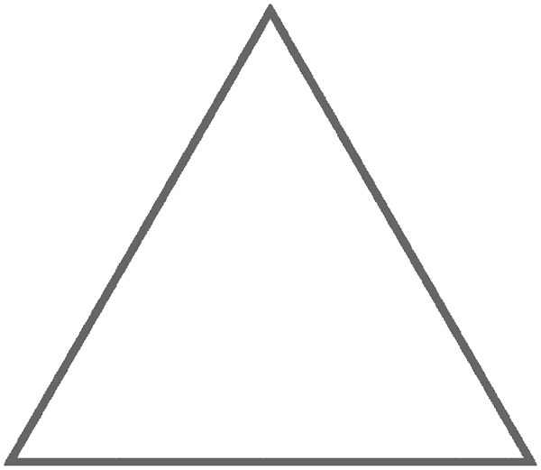

3 straight sides

3 vertices

1 right angle

# 3 straight sides

# 3 vertices

# all sides the same length

# 5 straight sides

5 vertices

# 6 straight sides

6 vertices

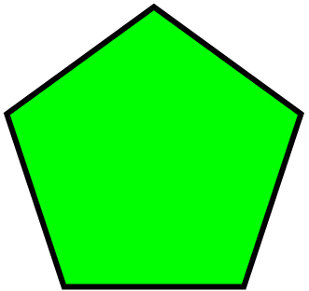

# 4 straight sides – all the same length. 4 right angled vertices

# 4 straight sides

# Opposite sides the same length.

# 8 straight sides

# 8 vertices

# 1 curved side. No vertices

# 1 straight side. 1 curved side. 2 vertices

# 7 straight sides. 7 vertices

# 1 curved side. No vertices