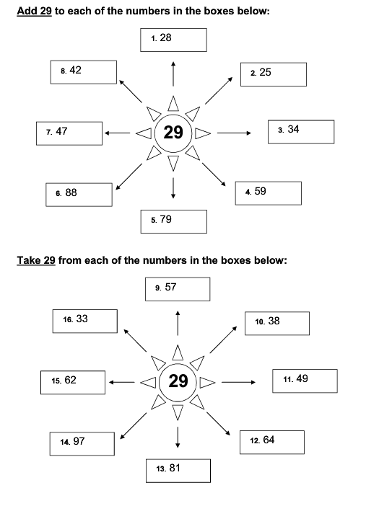
Adding and subtracting pairs of 2-digit numbers

