A school hall can fit 10 chairs in one row. How many rows are needed to seat 85 parents?



How many 100g jars are needed to store 550g of marmalade?



Felt tips are sold in packs 6. How many packets can be made up from 74 felt tips?



There are 13 players in a rugby team. How many teams could you form from 80 players?



There are 5 milk cartons in each pack. A school needs 64 cartons. How many packs does it need to order?



Matches are sold in boxes of 10. How many boxes can be filled from 75 matches?



How many 7-a-side football teams can be formed from 95 players?



6 people can sit at a table in a school dining room. How many tables are needed to seat 200 children?

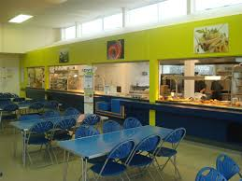

Tom wants to be an iPod costing £95. He saves £10 each week. How many weeks will it take him to save the money he needs?