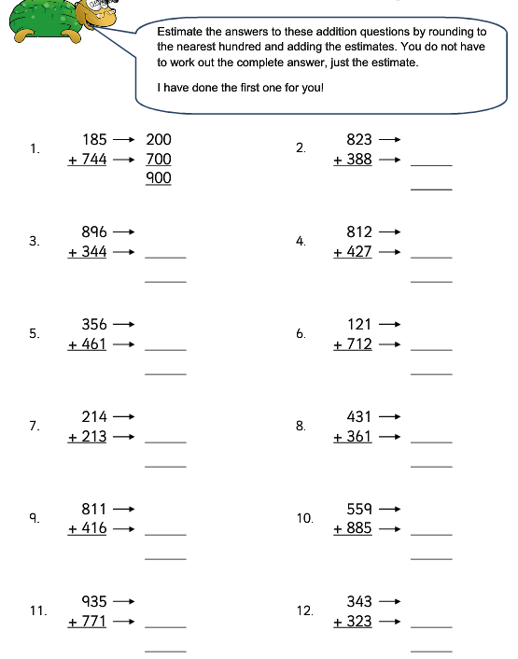
Estimate and Adding pairs of 3-digit numbers

