Ancient Egypt Research Project

Project Due Date: 9 March Presentation Date: 12 – 14 March
Description
During our study of Ancient Egypt, you will research a specific topic and create a PowerPoint presentation. Each research project must have a minimum of 3 sources from which you have found information, with at least one source being from paper.
Each student will have a maximum of two minutes to present his or her PowerPoint to the class.

Requirements

You will be graded on your PowerPoint and the oral presentation of your PowerPoint.

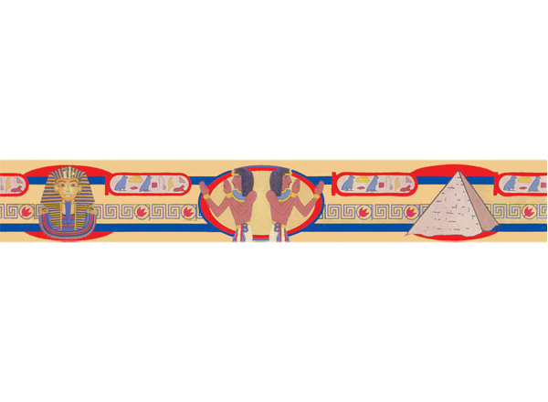
Each PowerPoint must have a minimum of 7 slides and a maximum of 10 slides. The first slide must be a Title slide with the title of your project, your name as well as the month and year in which you completed the project. At least 3 of the next slides must present key ideas from your research. You must incorporate at least 3 graphics or photographs into the presentation. The last slide must be a bibliography of the sources you used for your presentation. All information must be properly cited using the proper citation method.
See the example PowerPoint included here for more information.

Possible Research Topics
Pharaohs • Hieroglyphics • Pyramids • Mummies • Military • Animals of the Nile • Valley of the Kings •
The Sphinx • Social Classes • Farming and the Nile • Geography • Trade • Transportation • Astronomy •
Medicine • Technology • Education
Write your 1st, 2nd, and 3rd choice of research topic in the spaces below. You must select these topic choices no later than 2 March 2017.
1st Choice _____________________________________________
2nd Choice _____________________________________________
3rd Choice _____________________________________________
- Extension
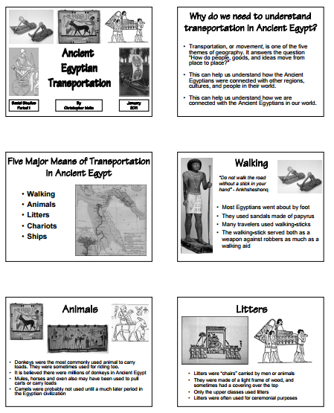
Students can work together to create their own Weebly page and then add their individual projects to the page. (Speak to your teacher if you are interested in participating in the extension task)

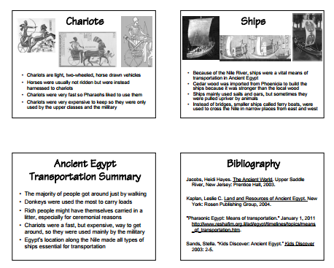
Example PowerPoint!

