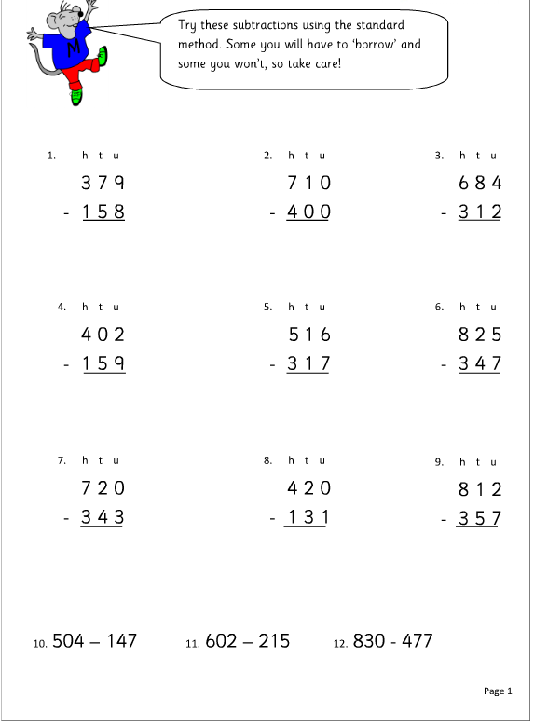
Subtracting pairs of 3-digit numbers

